REVERSE ENGINEERING — ACTIVITY REPORT

1. Physical Inspection — Studying the Product
- Product name/model – Samsung Galaxy J7 Duo
- Manufacturer – Samsung Electronics
- Approximate age/version – SM-J720F/DS
- External dimensions – 153.5 x 77.2 x 8.1 mm
- Buttons/switches – Home button on front; side buttons on either side (power on the right, volume on the left)
- LEDs/displays – 5.5-inch HD Super AMOLED
- Connectors – Micro USB (Type B) Charging Port
- Power source – 3000mAh removable Lithium Ion battery rated at 3.8V
- Ports – Micro USB (Type C) Charging Port
- Sensors – Accelerometer, proximity sensors, ambient-light/RGB light sensor, fingerprint sensor
- Mechanical interfaces – Removable rear cover and battery, SIM/microSD slots, display fitted into the front frame, physical home and side buttons, internal PCB/component mounting points, and mechanically mounted camera, speaker and sensor modules
- Labels and markings – Samsung logo on the back

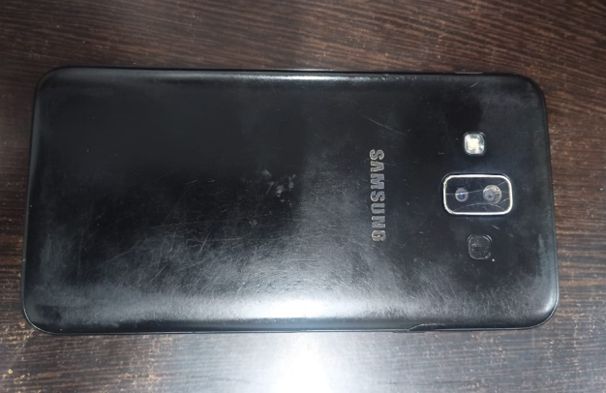

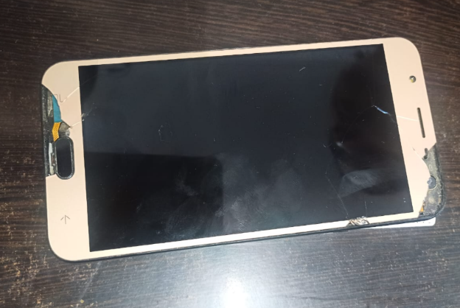

A. What is this product supposed to do?
Samsung Galaxy J7 Duo is a portable smartphone designed to combine communication, computing, photography, multimedia and internet connectivity in a single device.
B. What does the user expect?
A user purchasing a smartphone such as the Galaxy J7 Duo would expect:
- Portable size
- Reasonable weight
- Long battery life
- Good display quality
- Reliable cellular connectivity
- Good camera performance
- Sufficient storage
- Good audio
- Easy-to-use software
- Durable construction
C. What engineering decisions can we already infer?
From the external inspection of the Samsung Galaxy J7 Duo, several engineering decisions can be inferred. The phone has a relatively large display, indicating that the designers prioritized a comfortable viewing and touchscreen experience while keeping the device portable. The removable rear cover and battery indicate that the internal components were designed to be accessible for battery replacement and servicing. The physical home button with a fingerprint sensor provides both user interaction and biometric security. The placement of the camera, flash, buttons, speaker openings and ports shows that the internal components had to be arranged within a compact housing. Overall, the design suggests a balance between functionality, portability, cost, battery life and ease of use.
2. Product Literature Review
Parameter | Galaxy J7 (2017) | Galaxy J7 Duo
Processor | Exynos 7870 | Exynos 78885
Battery | Around 3600 mAh | 3000 mAh
Display | 5.5-inch | 5.5-inch
Android at Launch | Android 7.1 | Android 8.0
Rear Camera | Single | Dual 13mp + 5mp
PCB technology | Chipset: Samsung Exynos 7870 (14 nm)  CPU: Octa-core 1.6 GHz Cortex-A53  GPU: Mali-T830 MP1 [1] | Chipset: Samsung Exynos 7885 (14 nm)  CPU: Octa-core (2x2.2 GHz Cortex-A73 & 6x1.6 GHz Cortex-A53)  GPU: Mali-G71
Power consumption | The Galaxy J7 (2017) has superior overall endurance (rated at a 108-hour GSMArena endurance score) thanks to its larger 3,600 mAh battery and very low idle drain from the Exynos 7870 | The Galaxy J7 Duo features a lower HD screen resolution (saving some pixels-pushing overhead), but its performance CPU cores and stronger GPU consume more power when pushed, paired with a smaller 3,000 mAh capacity battery

The J7 Duo's Exynos 7885 and increased memory/storage represent a move toward greater performance and capability, while the dual-camera system adds photographic depth functionality. Samsung's launch material also highlighted App Pair as a multitasking feature.
Possible engineering reasons :
- Higher performance requirements
- Increased application demands
- Improved multitasking
- Greater storage requirements
- Improved photography
- Market demand for dual cameras
- Newer Android software
- Competition with other smartphones
3. Product Analysis — Group Discussion
Purpose :
What problem is this product solving?
The Samsung Galaxy J7 Duo solves the problem of needing multiple communication, entertainment, photography and computing functions in one portable device. It allows users to make calls, send messages, access the internet, take photographs, use applications, store information and communicate with other devices from a single smartphone.
User expectations :
What would users consider a good product?
Users would consider the Galaxy J7 Duo a good product if it provides reliable communication, good battery life, a responsive display, satisfactory camera performance, sufficient storage, smooth operation, secure access, good connectivity, clear audio and a durable, easy-to-use design.
4. Trade-offs
What compromises did the designer probably make?
Trade-off 1 — Performance vs Battery
A more capable processor can provide better performance but generally requires more power.
Higher processing capability
↓
Higher power requirement
↓
More heat / battery consumption
The J7 Duo therefore needs power-management circuitry between the battery and the different electronic subsystems.
Trade-off 2 — Screen size vs portability
A 5.5-inch display provides a larger viewing area but increases the overall dimensions of the phone.
Trade-off 3 — Camera capability vs space
The dual-camera system requires additional optical/electronic hardware while the designer still needs to fit everything inside a relatively thin phone.
Trade-off 4 — Battery capacity vs thickness
A larger battery could provide greater runtime but would require more internal space and potentially increase weight/thickness.
Trade-off 5 — Cost vs performance
The phone was positioned as a more affordable smartphone. Therefore, Samsung had to balance:
Larger battery → longer runtime → increased weight/thickness.
5. Photo Guide to Teardown
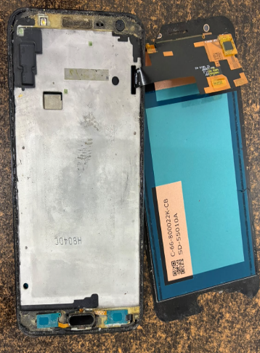
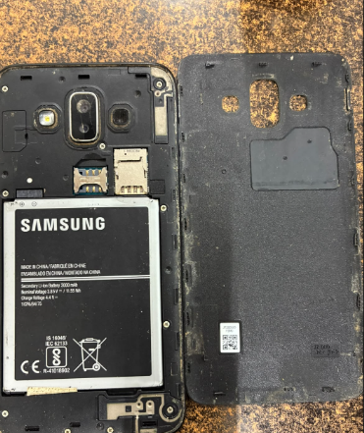
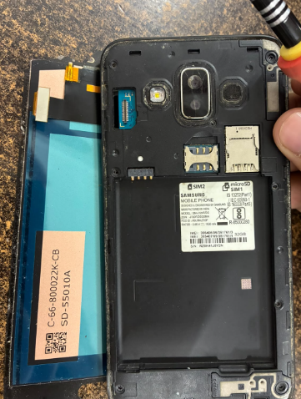
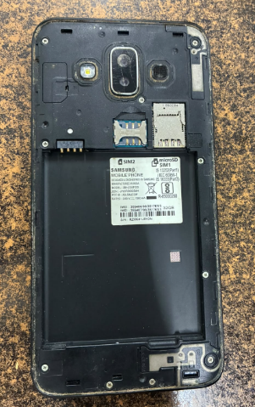

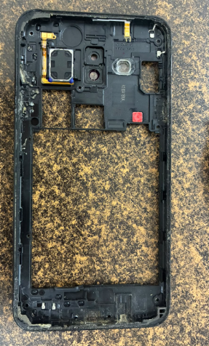
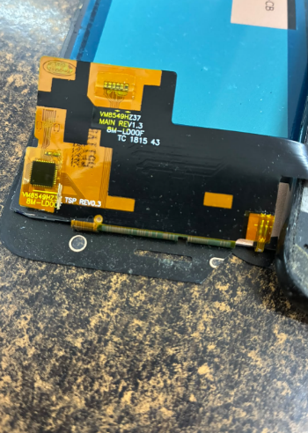
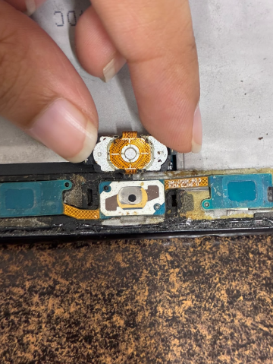
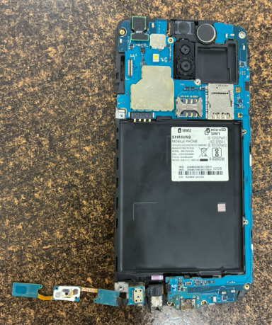
6. Internal Hardware Analysis
Ref. | Component | Function | Identification
BAT1 | Li-ion battery | Stores electrical energy | 3000 mAh battery
U1 | Main SoC | Processing/control | Exynos 7885 platform
U2 | PMIC | Power management | PCB marking required
U3 | Memory | RAM/storage | PCB marking required
DISP1 | AMOLED display | Visual output | 5.5-inch AMOLED
CAM1 | Rear camera | Image capture | 13 MP
CAM2 | Rear depth camera | Depth information | 5 MP
CAM3 | Front camera | Selfie/video | 8 MP
SPK1 | Loudspeaker | Audio output | To verify during teardown
MIC1 | Microphone | Audio input | To verify during teardown
FP1 | Fingerprint sensor | Biometric input | Rear-mounted
J1 | Micro-USB connector | Charging/data | USB 2.0
ANT1 | Antenna system | Wireless communication | To verify
S1 | Power key | User input | Side-mounted
S2 | Volume keys | User input | Side-mounted

Component Markings, Ratings & Specifications
PCB Reference | Marking | Manufacturer | Part Number | Function
U1 | Photograph marking | Samsung/other | To identify | Main processing
U2 | Photograph marking | To identify | To identify | Power management
U3 | Photograph marking | To identify | To identify | Memory
U4 | Photograph marking | To identify | To identify | Charging/power
U5 | Photograph marking | To identify | To identify | RF/communication

7. Component Functional Analysis
Component | Electrical role | Functional role
Battery | Electrical energy source | Powers phone
PMIC | Voltage/current regulation | Provides appropriate power rails
SoC | Digital processing | Runs operating system and applications
RAM | Temporary data storage | Supports active programs
Flash/eMMC | Non-volatile storage | Stores Android and user data
Display | Electrical-to-optical conversion | Displays information
Touch sensor | Detects touch | User input
Camera | Converts light to electrical/digital data | Photography/video
Microphone | Converts sound to electrical signal | Voice/audio input
Speaker | Converts electrical signal to sound | Audio output
Fingerprint sensor | Biometric sensing | User authentication
Accelerometer | Measures acceleration | Orientation/motion detection
Proximity sensor | Detects nearby objects | Screen/call functions
Light sensor | Measures ambient light | Automatic brightness
Antenna | RF transmission/reception | Wireless communication

8. Functional Block Diagram
┌─────────────────┐
│ BATTERY │
│ 3000 mAh │
└────────┬─────-─┘
│
▼
┌────────────────────┐
│ POWER MANAGEMENT│
│ / PMIC │
└────────┬──────────┘
│
┌─────────────┼─────────────────────┐
│ │ │
▼ ▼ ▼
┌────────────┐ ┌──────────────┐ ┌────────────┐
│ DISPLAY │ │ SoC │ │ SENSORS │
│ 5.5" AMOLED│ │ Exynos 7885 │ │ │
└────────────┘ └──────┬──────┘ └─────┬─────┘
│ │ │
┌───────────── ────┼────────────────┐
│ │ │
▼ ▼ ▼
┌──────────┐ ┌──────────┐ ┌─────────┐
│ RAM │ │ STORAGE │ │ CAMERAS│
└──────────┘ └──────────┘ └─────────┘
│
┌───────────────┼────────────────┐
│ │ │
▼ ▼ ▼
┌───────────┐ ┌────────────┐ ┌──────────┐
│ CELLULAR │ │ Wi-Fi/BT │ │ AUDIO │
│ RF │ │ │ │ │
└───────────┘ └────────────┘ └──────────┘
│
▼
┌──────────────┐
│ ANTENNAS │
└──────────────┘
9. Input–Process–Output Analysis
Inputs
- Touchscreen
- Physical buttons
- Camera
- Microphone
- Fingerprint sensor
- Accelerometer
- Proximity sensor
- Light sensor
- Cellular signals
- Wi-Fi signals
- Bluetooth signals
↓
Processing
Exynos processor + RAM + operating system + supporting ICs
↓
Outputs
- AMOLED display
- Speaker
- Vibration motor
- Cellular communication
- Wi-Fi communication
- Bluetooth communication
- Camera storage/results
This gives a simple explanation of how the phone operates as an engineered system.
10. Power Architecture
A simplified power path can be represented as:
Micro-USB
│
▼
Charging circuitry
│
▼
3000 mAh
Battery
│
▼
PMIC
│
┌─────┼──────┐
▼ ▼ ▼
SoC Display Sensors
│
├──── Memory
├──── Cameras
├──── Audio
└──── Communication

11. Final Reverse-Engineering Conclusions
Conclusion
The Samsung Galaxy J7 Duo is a compact smartphone that combines several engineering systems into one portable product. Its major subsystems include the battery and power-management system, processor, memory, display, camera modules, sensors, audio system and wireless communication system.
The external inspection shows that the phone was designed to provide multiple functions while maintaining a relatively compact form factor. Its 5.5-inch Super AMOLED display provides the primary visual interface, while the processor and memory system perform the required computational tasks. The dual rear-camera system provides enhanced photography capabilities, while sensors and the fingerprint system provide additional functionality.
The reverse-engineering process demonstrates that the phone is not simply a collection of individual components. Each component has an electrical and functional purpose, and the components must work together as a complete system.
The major engineering trade-offs include performance versus power consumption, battery capacity versus size and weight, camera capability versus internal space, and features versus manufacturing cost.
Therefore, studying the Galaxy J7 Duo through reverse engineering helps reveal the engineering decisions involved in creating a consumer electronic product and demonstrates how mechanical, electrical and software systems are integrated into a single device.

